Unit 2: Exploring Derivatives MVC4U

Lesson Outline

Big Picture

Students will:
- make connections between functions (polynomial, sinusoidal, exponential) and their corresponding derivative functions;
- determine, using limits, the algebraic representation of the derivative of polynomial functions at any point;
- use patterning and reasoning to investigate connections between the graphs of functions and their derivatives;
- make connections between the inverse relation of and
Day | Lesson Title | Math Learning Goals | Expectations
1 | Intervals of Rates of Change | - Determine intervals in order to identify increasing, decreasing, and zero rates of change using graphical and numerical representations of polynomial functions.  - Describe the behaviour of the instantaneous rate of change at and between local maxima and minima. | A2.1  CGE 3c, 5h
2 | The Instantaneous Rate of Change Functions  GSP® files:  Group One:.gsp  Group Two: .gsp  Group Three: .gsp  Group Four: .gsp | - Use numerical and graphical representations to define and explore the derivative function of a polynomial function with technology.  - Make connections between the graphs of the derivative function and the function. | A2.2  CGE 2c, 4f, 5a
3 | Derivates of Polynomial Functions  (lesson not included) | - Determine, using limits, the algebraic representations of the derivative of polynomial functions at any point. | A2.3
4 | Patterns in the Derivative of Sinusoidal Functions  (lesson not included) | - Use patterning and reasoning to investigate connections graphically and numerically between the graphs of and their derivatives using technology. | A2.4
5 | Patterns in the Derivative of Exponential Functions  (lesson not included) | - Determine the graph of the derivative of using technology.  - Investigate connections between the graph of and its derivative using technology. | A2.5
6 | Identify “e”  (lesson not included) | - Investigate connections between an exponential function whose graph is the same as its derivative using technology and recognize the significance of this result. | A2.6
7 | Relating f(x) = ln(x) and f(x) = e^{x}  (lesson not included) | - Make connections between the natural logarithm function and the function  - Make connections between the inverse relation of and | A2.7
Day | Lesson Title | Math Learning Goals | Expectations
8 | Verify Derivatives of Exponential Functions  (lesson not included) | - Verify the derivative of the exponential function is for various values of a, using technology.
9 | Jazz Day/ Summative Assessment
10–11 | Power Rule  (lessons not included) | - Verify the power rule for functions of the form (where n is a natural number).  - Verify the power rule applies to functions with rational exponents.  - Verify numerically and graphically, and read and interpret proofs involving limits, of the constant, constant multiple, sums, and difference rules. | A3.1, A3.2  A3.4
12 | Solve Problems Involving the Power Rule  (lesson not included) | - Determine the derivatives of polynomial functions algebraically, and use these to solve problems involving rates of change. | A3.3
13–15 | Explore and Apply the Product Rule and the Chain Rule  (lessons not included) | - Verify the chain rule and product rule.  - Solve problems involving the Product Rule and Chain Rule and develop algebraic facility where appropriate. | A3.4 A3.5
16–17 | Connections to Rational and Radical Functions  (lessons not included) | - Use the Product Rule and Chain Rule to determine derivatives of rational and radical functions.  - Solve problems involving rates of change for rational and radical functions and develop algebraic facility where appropriate. | A3.4  A3.5
18–19 | Applications of Derivatives  (lessons not included) | - Pose and solve problems in context involving instantaneous rates of change. | A3.5
20 | Jazz Day
21 | Summative Assessment

Unit 2: Day 1: Intervals of Rates of Change |  |  |  |  | MVC4U
  75 min |  | Math Learning Goals  - Identify increasing and decreasing rates of change using graphical and numerical representations of polynomial functions.  - Investigate connections graphically and numerically between the graph of a polynomial function and the graph of its derivative using technology. |  |  | Materials  - BLM 2.1.1, 2.1.2  - flashlight
Assessment
Opportunities
 | Minds On… | Whole Class → Discussion  Provide students with tables of values (numerical representation) of quadratic, linear, exponential functions.  Students identify when the rate of change is positive and when it is negative and describe what that means in terms of the behaviour of the rate of change for each example. Make connections to finite differences over constant intervals. Students assess the behaviour of the rate of change.  Demonstrate how to describe the rate of change of a function when given the graphical representation of the function (BLM 2.1.1).
 | Action! | Small Groups → Experiment  Use the first example on BLM 2.1.2 to help students describe the behaviour of the rate of change of a function given its graphical representation. Students complete the worksheet.  Students generate graphs of functions for other students in the group to analyse.  Learning Skills/Teamwork/Checkbric: Circulate recording students’ teamwork performance on the checkbric.  Mathematical Process Focus: Representing, Connecting
 | Consolidate Debrief | Whole Class → Discussion  Describe functions using the information about the sign of the rate of change. Students generate examples of tables of values and graphs of functions that model the information provided, e.g., generate an example of a table of values or a graph of a function that has a negative rate of change for x < –3, a rate of change of zero from x = –3 to x = 3 and a positive rate of change for x > 3.
Application |  | Home Activity or Further Classroom Consolidation  Students reinforce the skills developed in this lesson. |  | Provide questions that reinforce the topic.

2.1.1: Illuminating Rates of Change (Teacher)

Use a flashlight in two different ways to demonstrate rates of change of a function over intervals between local maxima and minima.

Set-up
Display a graph of a smooth function on the board (IWB, chalk board, whiteboard,..). As an image surface, there should be a wall or other flat surface perpendicular to the board.

Part 1
Use a flashlight to trace the curve at a constant speed, keeping the flashlight horizontal against the board. Have students watch the beam of light as it strikes the image surface. The light will move quickly up or down the image surface when the rate of change is a high value and will move slowly when the rate of change is a low value. Demonstrate with different familiar functions, as needed.

Part 2
Instantaneous rate of change: Students have seen that the instantaneous rate of change is the slope of the tangent at a specific point. Using one of the functions from the first part of the activity and the flashlight, demonstrate the tangents at various points on the graph. The graph can again be traced using the flashlight (a ruler may be a better choice for some in order to easily find the slope of the tangent from the graph) This time the light must remain tangent to the graph at all times. Complete a table, to create a set of points that can be plotted (x, y’) where x is still x and y’ is now the slope of the tangent.
2.1.2: Recognizing Changes in the Instantaneous
Rates of Change

For each graph, divide the domain into intervals using local minima and maxima and determine the intervals where the instantaneous rate of change is negative or positive. The first one is done for you.

a)
  Domain | Sign of Instantaneous Rate of Change
  < A | negative
  at A | zero
  > A | positive

b)
  Domain | Sign of Instantaneous Rate of Change
  < O
  at O
  between O and P
  at P
  between P and Q
  at Q
  Q >

2.1.2: Recognizing Changes in the Instantaneous
Rates of Change (continued)

c)
  Domain | Sign of Instantaneous Rate of Change

d)
  Domain | Sign of Instantaneous Rate of Change

Unit 2: Day 2: The Instantaneous Rate of Change Functions |  |  |  |  | MVC4U
75 min |  | Math Learning Goals  - Generate, through investigation using technology, a table of values showing the instantaneous rate of change of a polynomial function,for various values of x, graph the ordered pairs, recognize that the graph represents the instantaneous rate of change function called the derivative function and represented using  - Make connections between the graphs and equations of and |  |  | Materials  - BLM 2.2.1, 2.2.2, 2.2.3, 2.2.4  - graphing technology
Assessment
Opportunities
 | Minds On… | Pairs → Exploration  Students describe the behaviour of the average rate of change for the function They use first and second differences to investigate how the average rate of change for the function changes and conjecture what type of function could model this behaviour. |  | Assessment opportunity for learning skills available when students are working in their groups.  Group One:.gsp  Group Two: .gsp  Group Three: .gsp  Group Four: .gsp
 | Action! | Whole Class → Teacher Directed Investigation  Students describe algebraically, the behaviour of the instantaneous rate of change for the function They use slopes of tangents to investigate how the instantaneous rate of change for the functionchanges and how to model this behaviour algebraically.  Small Groups → Jigsaw → Investigation  Expert groups use patterning to investigate the relationship between the equations of a group of similar polynomial functions and the equations of their instantaneous rate of change function. The instantaneous rate of change function is described as the derivative function or simply the derivative and is represented using the notation  Learning Skill/Collaboration/Observation: Observe students collaborative skills as they work in groups.  Mathematical Process Focus: Connecting, Selecting Tools and Strategies
 | Consolidate Debrief | Small Groups → Jigsaw  Students regroup to share their expertise with students from other groups. They work together to conjecture what the graphical and algebraic connections are between a polynomial function and its derivative.  Whole Class → Discussion  Discuss and consolidate the group observations. Provide some examples for students to work on.
Application  Skill Drill |  | Home Activity or Further Classroom Consolidation  Complete the practice questions. |  | Provide exercises that allow for more practice and applications that reinforce the meaning of the derivative.

2.2.1: Behaviour of Average Rate of Change for f(x) = x²

Describe the behaviour of the average rate of change for the function Use first and second differences to investigate how the average rate of change for the function changes.

Complete the table below for

x |  | First Differences | Second Differences
–4 |  | First Differences | Second Differences
–3
–2
–1
0
1
2
3
4

What connection can you make between the first difference when x = 1 and x = 2, the secant with endpoints (1,1) and (2,4) and the average rate of change ofbetween x = 1 and x = 2?

For the function what do the second differences suggest about how the average rate of change varies?

What type of function (e.g., linear, quadratic, exponential, trigonometric) best models the changes in the average rate of change?

2.2.2: The Instantaneous Rate of Change Function for f(x) = x²

Describe the behaviour of the instantaneous rate of change for the function algebraically. Use the slopes of tangents to investigate how the instantaneous rate of change for the functionchanges and how to describe that relationship algebraically using a function.
Use graphing technology (e.g., graphing calculators, Geometer’s Sketchpad, Winplot) to graph the function Create a movable tangent to the function and show the slope of the tangent for any point on the function (see BLM 2.2.4: or use GSP® sketch and select tab one).
To determine the equation of the instantaneous rate of change function, move the tangent to the functionover to the point where x = –4. Use the slope of the tangent to record the instantaneous rate of change of the function when x = –4. Repeat for the other values of x in the table. To distinguish the function from the instantaneous rate of change function, use the symbolto describe the instantaneous rate of change function.  Graph the rate of change function (plot the points) on the graph below and determine the algebraic equation of the instantaneous rate of change function.
  Function: |  | Instantaneous Rate of Change Function
  x |  | x
  –4 | 16 | –4
  –3 | 9 | –3
  –2 | 4 | –2
  –1 | 1 | –1
  0 | 0 | 0
  1 | 1 | 1
  2 | 2 | 2
  3 | 4 | 3
  4 | 16 | 4
Algebraic Equation of Rate of Change Function:
2.2.3: The Instantaneous Rate of Change Function for
Simple Polynomials

Use patterning to investigate the relationship between the equation of a function and the equation of its instantaneous rate of change function. The instantaneous rate of change function is called the derivative function or simply the derivative and is represented using the notation

In your group, work with the assigned function:
Group One:
Group Two:
Group Three:
Group Four:

Use graphing technology (e.g., graphing calculators, The Geometer’s Sketchpad®, or Winplot) to graph each function in the group. Create a movable tangent for each function and use the slope of the tangent to the function to determine the instantaneous rate of change of the function at that point. Record your data in the tables provided and determine the equation of the derivative function:

 |  | Derivative Function |  |  |  |  | Derivative  Function
x |  | x |  |  | x |  | x
–4 |  | –4 |  |  | –4 |  | –4
–3 |  | –3 |  |  | –3 |  | –3
–2 |  | –2 |  |  | –2 |  | –2
–1 |  | –1 |  |  | –1 |  | –1
0 |  | 0 |  |  | 0 |  | 0
1 |  | 1 |  |  | 1 |  | 1
2 |  | 2 |  |  | 2 |  | 2
3 |  | 3 |  |  | 3 |  | 3
4 |  | 4 |  |  | 4 |  | 4
Use the numerical values of the derivative to determine the equation of the derivative function. |  |  |  |  | Use the numerical values of the derivative to determine the equation of the derivative function.

2.2.3: The Instantaneous Rate of Change Function
for Simple Polynomials

 |  | Derivative Function |  |  |  |  | Derivative Function
x |  | x |  |  | x |  | x
–4 |  | –4 |  |  | –4 |  | –4
–3 |  | –3 |  |  | –3 |  | –3
–2 |  | –2 |  |  | –2 |  | –2
–1 |  | –1 |  |  | –1 |  | –1
0 |  | 0 |  |  | 0 |  | 0
1 |  | 1 |  |  | 1 |  | 1
2 |  | 2 |  |  | 2 |  | 2
3 |  | 3 |  |  | 3 |  | 3
4 |  | 4 |  |  | 4 |  | 4
Use the numerical values of the derivative to determine the equation of the derivative function. |  |  |  |  | Use the numerical values of the derivative to determine the equation of the derivative function.

Summary

Record the equations from this investigation in the summary table below:

Function | Derivative Function

What relationship can you observe between the graphs of the polynomial functions in your group and the graphs of their derivatives?
Between the equations of the polynomial functions in your group and the equations of their derivatives?
Bring your expertise to a group with representatives from each of the function groups. Share your results with the class.

2.2.4: The Instantaneous Rate of Change Function for (Teacher)

The directions below show how to use graphing technology The Geometer’s Sketchpad® and Winplot to graph the functionto create a movable tangent to the function and to show the slope of the tangent for any point on the function.

The Geometer’s Sketchpad® Version:
- Select Graph then Show Grid.
- Select New Function then enter x² and OK.
- Select Graph then Plot Function.
- Click on the graph then click on the graph of the function. Select Construct and Point on Object.
- Repeat the step above to create a second point on the function.
- Deselect all then click the two points on the graph then select Construct and Line.
- Select Measure and Slope.
- Move the two points together to approximate the tangent.
- Grab the tangent and move it along the graph.

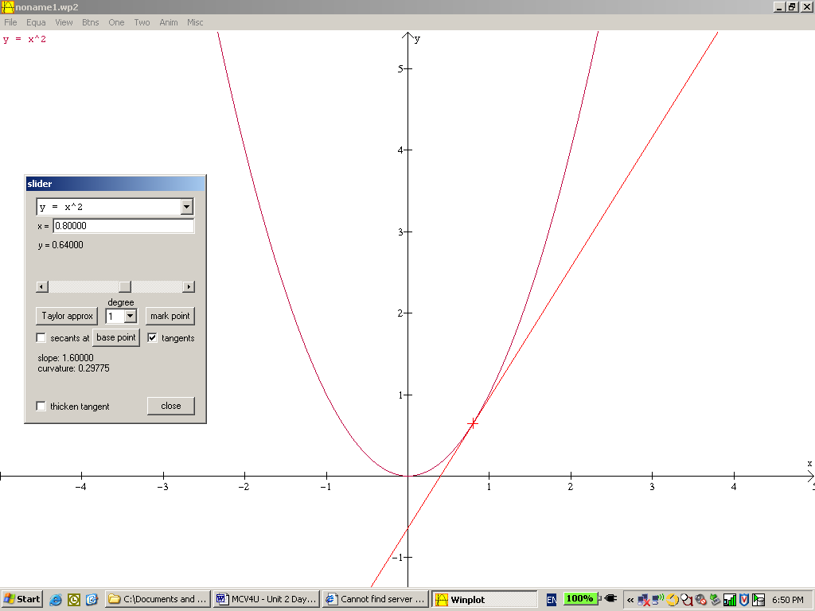 | - Select Equa and 1. Explicit and enter x² forand OK.  - Select Equa and Inventory and Equa.  - Select One then Slider.  - A pop-up box appears. Check off the Tangents box. Move the pop-up box to the side so it does not cover your graph.  - Slide the slider and watch the tangent move along the function.  - Note the slope of the tangent in the lower half of the pop up box.

GSP® Files

Group One ax² | Group Two ax³
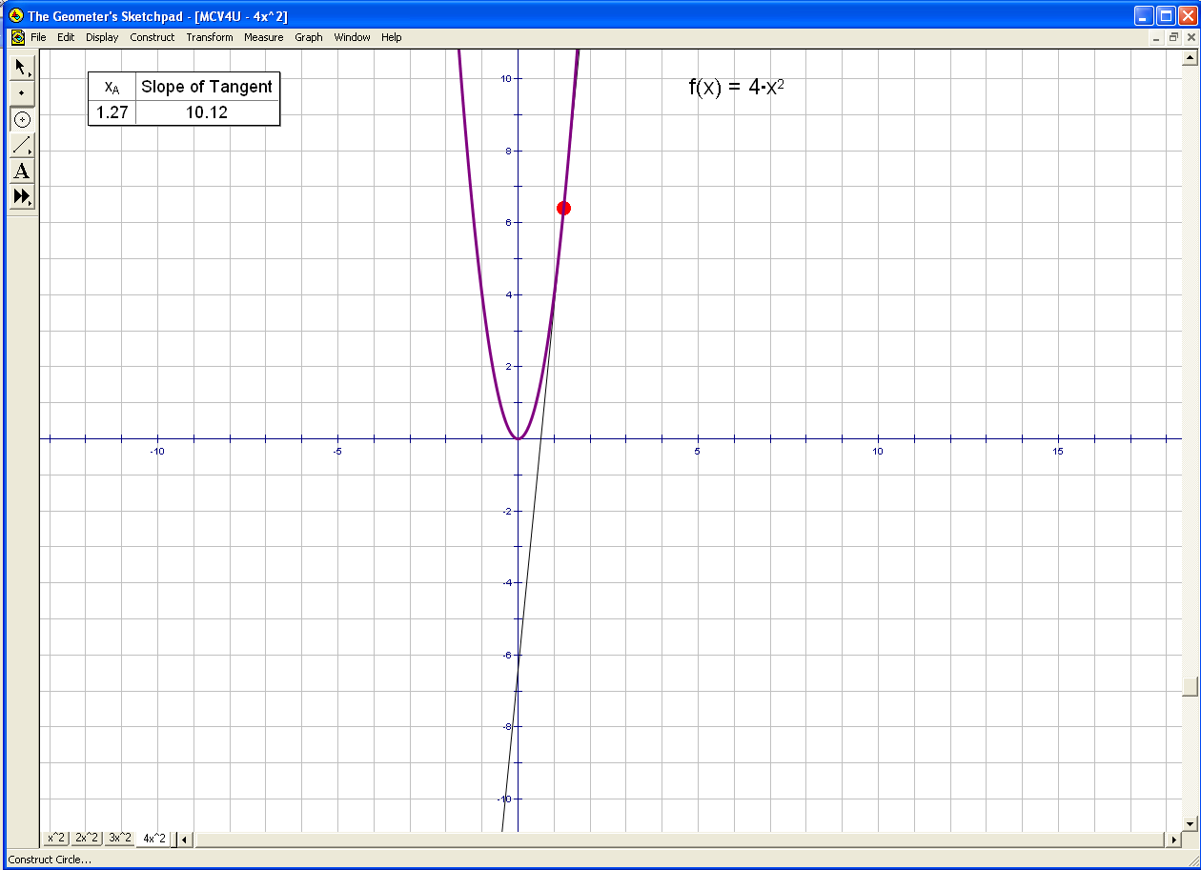 | 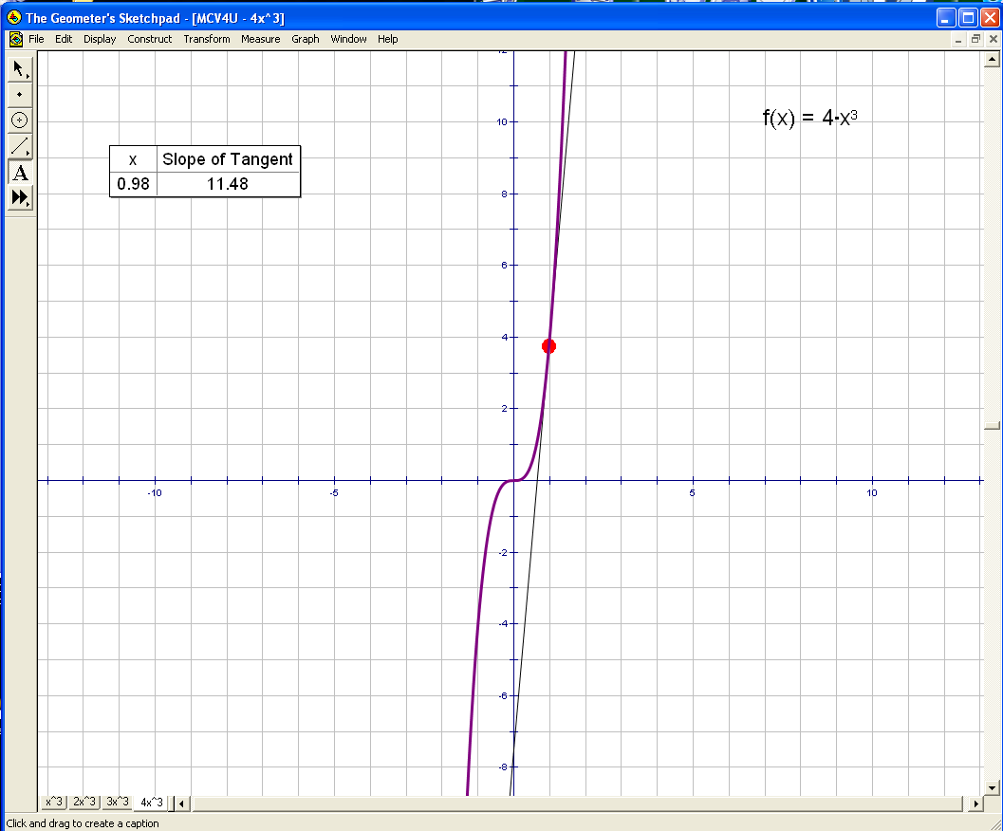
Group Three x² + ax | Group Four x³ + ax²
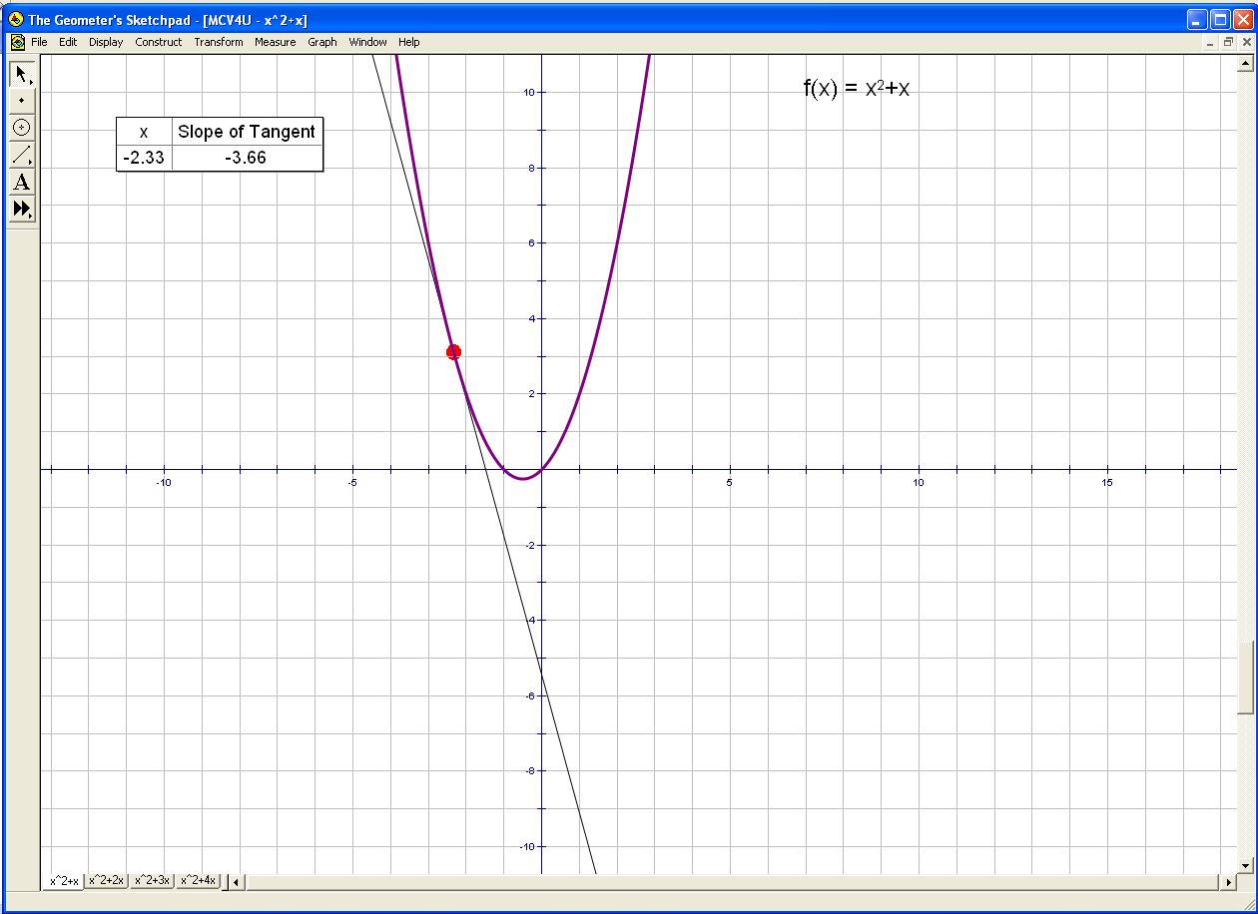 | 